PRESENDED BY

JAYAPRIYA R -912520104013

INDHUMATHI E -912520104011

SIVATHARSHINI S -912520104029

MANOJ A -912520104303

SURYA M -912520104030

INTELLIGENT PEOPLE AND VECHICLE COUNTING SYSTEM FOR SECRETARIAT

ABSTRACT
This work was carried out to determine the performance of image processing techniques in classifying and counting moving vehicles in video streams of traffic scenes recorded by stationary cameras. The detection and tracking approach is as follows. The moving vehicles are first extracted from the traffic scene by applying the adoptive background subtraction technique. After the background subtraction, using threshold and median filters, isolated image blobs are identified as individual vehicles. Once the blobs are identified, counting and classification of vehicles in a selected region are carried out.
The preliminary results show that the developed system can efficiently and reliably track vehicles when unobstructed view of the traffic scene can be obtained. For optimal camera calibration, an accuracy better than 80% in counting vehicles was observed. The present system performs better with video data in which the vehicles are moving away from the camera compared to the video data in which the vehicles are moving towards the camera. The results obtained through the developed system show that with further improvements the system can be used in real-time to count and classify vehicles on busy traffic routes.

- INTRODUCTION
Traffic management has become an important daily routine in cities today with the exponential growth of traffic on roads. Automatic vehicle detection from traffic scenes and extracting essential parameters related to vehicular traffic can help better management of traffic on busy highways and road intersections. Monitoring traffic flow and estimating traffic parameters can be carried out using sensors [1, 2] as well as through image processing techniques.
With the advances in technology, monitoring traffic through image processing techniques yield a wide
range of traffic parameters such as flow of traffic, speed of vehicles, number of vehicles, classification of vehicles, density of vehicles etc. Since the vehicles can be tracked over a selected segment of a roadway, rather than at a single point, it is possible to measure the “true” density of vehicles for each lane. Image processing techniques can also be applied to traffic video surveillance to detect the vehicles in motion, number plate identification, recognition of obstacles etc. Traffic monitoring through image processing techniques can lead to better control of the flow of traffic as well as to identification of reckless users and speed violators.

In the past, many research studies have been conducted on automated vehicle detection using image processing techniques. The focus of this project was to test the performance in identifying the moving vehicles from a traffic scene and to count and classify vehicles within a given time period.

The following are the required processing steps:
- Converting a video stream to a sequence of single frames.
- Detecting a stable image from a dynamically changing background image.
- Calibration of the camera.
- Identification of vehicles.
- Tracking moving vehicles in each lane.
- Counting vehicles.
- Classifying vehicles.

The paper starts with a brief overview of related work followed by a description of the approach including segmentation, calibration, tracking, and classification. The paper concludes with results and final conclusions.

- RELATED WORK
In reference [3], a system for detection and classification of vehicles is described. It uses a self

adaptive background subtraction technique to separate vehicles from the background. The resulting connected regions are then tracked over a sequence of images using a spatial matching method. The tracked regions are grouped together to form vehicles. Reference [4] also uses adaptive background detection method to identify vehicles. The vehicles are tracked based on contour extraction. Prewitt filter kernel is used for edge detection. The contour linking method used for connecting separated edge parts of the original object into one closed contour. A contour labelling method is used to mark and calculate vehicles within frames. In reference [5], feature based tracking algorithm has been used. Offline camera calibration has been carried out to detect the parameters such as line correspondences for a projective mapping, detection region and multiple fiducially points for camera stabilization. Here, projective transformation is necessary as the features are tracked in world coordinates to exploit known physical constraints on vehicle motion. The transformation is used to calculate distance based measures such as position, velocity and density. In reference [6], adaptive background learning for vehicle detection and spatio-temporal tracking is described. A framework is proposed to analyze the traffic video sequence using unsupervised vehicle detection and spatio-temporal tracking that includes an image/video segmentation method, a background learning/subtraction method and an object tracking algorithm. In reference [7], a system on vehicle detection under day and night illumination is described. Vehicle detection at day time is done by using consecutive three frame subtraction method by detecting moving points. The moving points are classified and labelled as vehicles. Vehicle detection at night time is done by identifying vehicles in terms of pair of headlights. To detect only the objects related headlights, the system perform detection via morphological analysis, by taking into account aspects like shape, size and minimal distance between vehicles. Finally, the verification is based on the correlation between headlights belonging to the same pair. In reference [8], a system for fast vehicle detection with probabilistic feature grouping and its application to vehicle tracking is described. The images were obtained from three cameras installed on a roof of a
30-story building alongside a freeway in order to avoid overlapping of vehicles. System introduces a new vehicle tracking approach based on a model- based 3-D vehicle detection and description algorithm. The proposed algorithm uses a probabilistic “line” feature grouping method to detect vehicles. The tracking is performed based on the zero-mean cross correlation matching technique. System detects vehicles at the entrance area and track the detected vehicles based on their intensity profiles. In reference [9], a system for vehicle detection and tracking is described. This system is fully based on the Block Matching Algorithm (BMA), which is the motion estimation algorithm employed in the MPEG compression standard. BMA partitions the current frame in small, fixed size blocks and matches them in the previous frame in order to estimate displacement of blocks between two successive frames. The detection and tracking approach is as follows. BMA provides motion vectors, which are then regularised using a Vector Median Filter. After the regularisation step, motion vectors are grouped based on their adjacency and similarity, and a set of vehicles is identified per singular frame. Finally, the tracking algorithm establishes the correspondences between the vehicles detected in each frames of the sequence, allowing the estimation of their trajectories as well as the detection of new entries and exits. The tracking algorithm is strongly based on the BMA. It consider the BMA output as the basic tracking information associated with each block and combine this information with the already available block-level tracking as a grouped output in order to achieve the desired result.

- METHEDOLOGY
This section presents the essential steps in project implementation, starting from a video clip of a traffic scene and ending in vehicle classification and counting. The work was carried out with freely available video clips of traffic scenes.
  - Background Detection
To extract stable background image, adaptive background detection method was used [3]. This method uses mean value of pixels within a range of frames to detect the background. If the variance of a given pixel is below a predefined threshold, then the

pixel is considered to be stable. The background image is updated according to the equation given below.

B_{t+1} = B_{t} + S_{t} ×M_{t}

Here, B_{t} is old background image, S_{t} is a mask which varies between 0 and 1 depending on the variance and M_{t} is mean value of pixels.
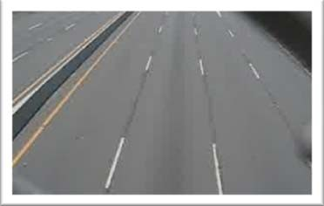

Fig 1: Stable background image
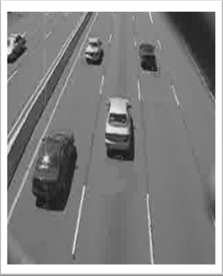

Fig 2: Image under investigation
  - Camera Calibration
Camera calibration plays an important role in the identification process. Camera calibration is carried out to transform the image coordinates to world coordinates [5]. This is essential for the vehicle classification. It is also important if one wishes to extract the speed of the vehicles. In this work following assumptions were taken.
- Road is straight
- Road is flat
- X axis of the road space correspond to the direction perpendicular to the traffic flow and the Y axis is parallel to the traffic flow.
The transformation that has been carried out from the image space to world space is the projection transformation. Assume that the width and the length of the selected area in road space (which are known) are w and h respectively. The equation to
find the projective transformation matrix that maps the image space coordinates (ax,ay; bx,by; cx,cy; dx,dy) to their corresponding road space coordinates is;
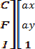
=

To optimize the results of projection transformation matrix, least squares optimization method was used. The projection transformation was used as the initial guess and the best projection matrix was found by using the following objective function [5].
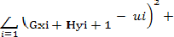

  - Lane Calibration
Since the goal of the project is to identify the vehicles in each lane separately, the lanes must be defined and the centreline of each lane must be identified. User is allowed to select the region of interest by selecting the centre of lanes first and then the starting and ending points on each lane to define the tracking region. The screen space coordinates were first transformed into road space coordinates and then projected onto the lane line.
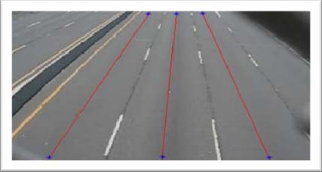
Fig 3: Selected centreline on each lane
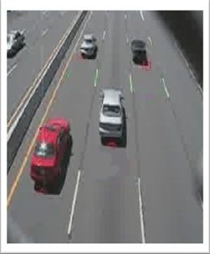
Vehicles were tracked alone the centreline on each lane within the user define tracking area.

Fig 4: Current frame and extracted pixels on lane lines
  - Vehicle Tracking
Numerous techniques have been developed to track moving objects in tracking regions such as tracking points, tracking centroids, tracking rectangles etc. In this work, the bottom coordinates of the identified objects have been used to track moving vehicles in the selected area.
While reading new frame, beginning of the centreline of interest has been examined and if a positive value (here it is 1) is seen, the algorithm considers it as the bottom coordinate of a vehicle. If a positive value was seen in the previous frame and it has now changed, it suggests that the vehicle is in motion in the selected region of interest. By detecting the column vector having top to bottom positive stream of values the vehicle could be detected. Figure 5 illustrates the stated algorithm.

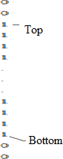

Fig 5: Binary pixel value of column vector of an identified vehicle
By calculating the length of the positive column vector which is the difference between the top and the bottom pixel values of the positive stream of numbers and convert it to the world coordinate space, minimum length of vehicle could be verified. Vehicles that do not satisfy the minimum length requirement were rejected. If a new vehicle is found, it is added to the vehicle array of the lane.
For each vector in the vehicle array, algorithm starts from the last known position of the bottom of the
vector and search forward along the centreline to find the next position of the vector in the next frame. If the search ended up in reaching the end of the region, the vehicle is considered to be exited from the region of interest. This process is repeated for all defined centerlines.
  - Vehicle Classification
Classification is done by categorizing the vehicles into three classes according to the size of the vehicles, namely, large, medium and small. Since it is easy to find the length of vectors, the length has been taken as the parameter to classify vehicles according to the defined sizes. The following table shows the classification used in this work.

Large | Containers, Lorries, Buses
Medium | Cars, Vans, Pickups
Small | Two wheelers, Three wheelers
Table 1: Classification of vehicles
For each new vehicle that enters into the line on the region of interest, the length of vector has been calculated and subjected to the minimum length requirement. Classification was carried out for those vehicles that pass the length requirement.
- RESULTS AND DISCUSSION
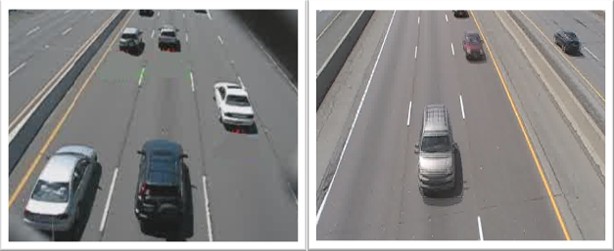
Since the success of the project depend on providing a proper line of site for the camera view, placing the camera on an overhead bridge directly over the flow of traffic route was necessary to minimize the vehicle occlusion. Due to security situation in the country, tests were carried out (to debug the developed algorithms and to evaluate the performance) with freely available video clips on internet, one with vehicles moving away from the camera view and another with vehicles moving towards the camera view (see Figure 6).

Fig 6: Video clips used to test the developed algorithms
The accuracy of the results depends on the camera calibration which takes place to find the projection matrix between the image coordinate and the world coordinate, lane selection and the tracking region. The system has been tested with several camera calibrations to find the optimum results. Figure 7 illustrates results of two camera calibrations for the video clip 1.
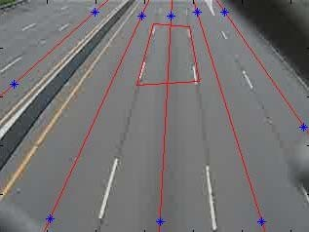
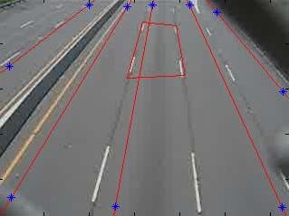

Fig 7: Camera calibrations (1) Optimum calibration
(2) Improper lane selection
In order to reach the desired goal, the video clips were subjected to a series of independent tests that were discussed earlier to carry out vehicle identification, tracking, classification and counting.
For the video clip 1, manually counted results and counting results of the developed system (CCT system) for each lane is given in Table 2. Here, in lane 1, vehicles are moving towards the camera and in lane 2, lane 3, lane 4 and lane 5, vehicles are moving away from the camera view.

Calibration | Lane 1 | Lane 2 | Lane 3 | Lane 4 | Lane 5
Manual | 32 | 36 | 38 | 41 | 4
CCT System | 32 | 37 | 42 | 36 | 12
Table 2: Comparison between actual counting and CCT system counting
It can be seen that except for lanes 4 and 5, other 3 lanes produce results within 10% of the manual counting. As expected, errors increase when the
lanes are skewed in the camera view. The developed system tends to produce errors especially when the vehicles do not travel within the selected lanes and when tall vehicles (such as containers) tend to be in the side lanes often covering two lanes in the camera view.
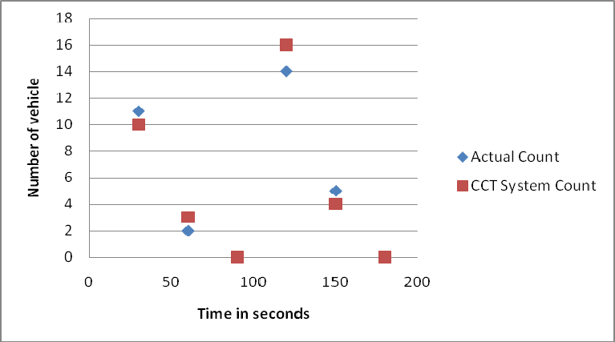
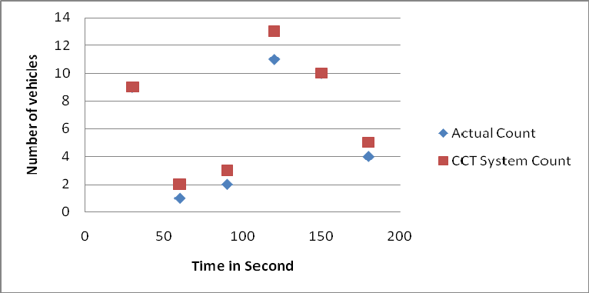

Fig 8: Comparison of counting results for different time intervals for lane 1 and 3
In order to check the performance of the CCT system with the traffic flow rate, data were collected for time intervals of 30 seconds. Figure 8 shows the results obtained for different time intervals for lane 1 and lane 3 for video clip 1.
The classification of identified vehicles was carried out according to the definitions given in Table 1. The main criterion used in the CCT system to classify the vehicles is the length of the vehicles. Figure 9 shows the comparison of vehicle classification between actual classification (visual) and CCT system classification for total (1), large (2), medium (3) and misidentification (4).

- CONCLUSIONS
Preliminary results for developing an automated system for counting and classification of vehicles in motion, based on image processing techniques were presented in this paper. The developed system was able to track vehicles and classify them with a reasonable accuracy. The system is capable of handling video clips of traffic scenes with 15 frames per second in real time.
The results strongly depend on the camera calibration used. If the camera calibration is not optimal, it can easily affect the system performance. When the camera calibration is optimal, developed system showed an accuracy of 93% for lane 1, 97% for lane 2 and 90% for lane 3. As expected, lane 5, which is the furthest lane from camera view and often obstructed due to heavy vehicles showed poor performance in counting.
The results obtained through the developed system show that with further improvements it can be used in real-time to count and classify vehicles on busy traffic routes. Especially, if an obstructed view of the traffic movement can be obtained, the system can perform quite accurately.
- ACKNOWLEDGMENT
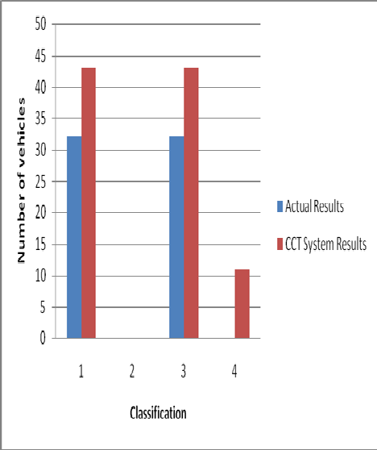
Financial assistance given by the National Science Foundation, Sri Lanka for the research grant number RG/07/E/03 is greatly acknowledged.

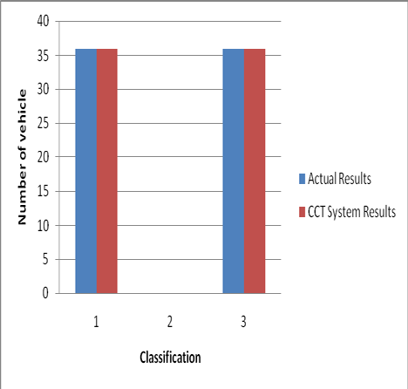
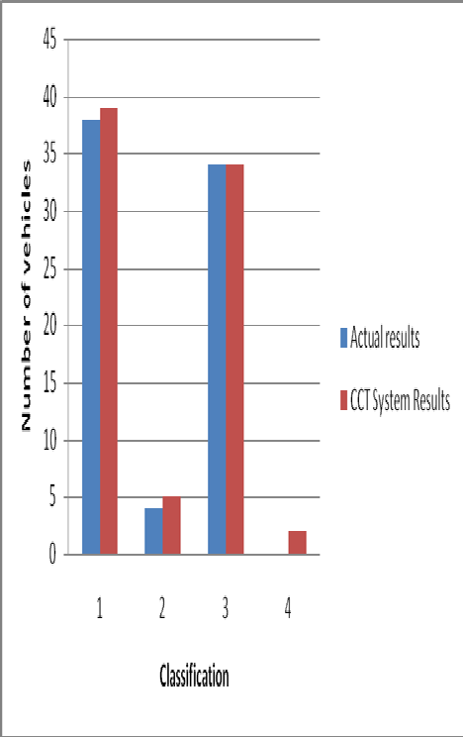
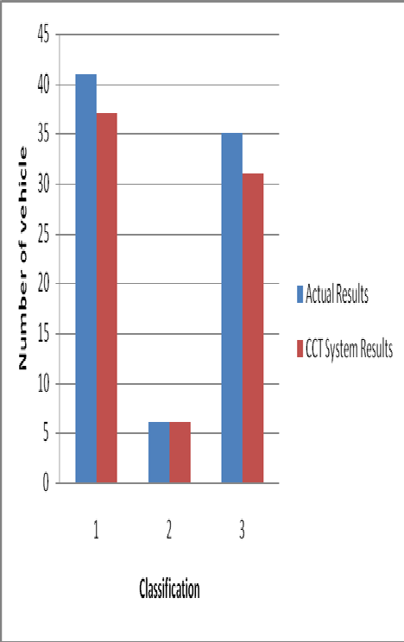

Fig 9: Comparison of classification between actual and CCT system for each lane

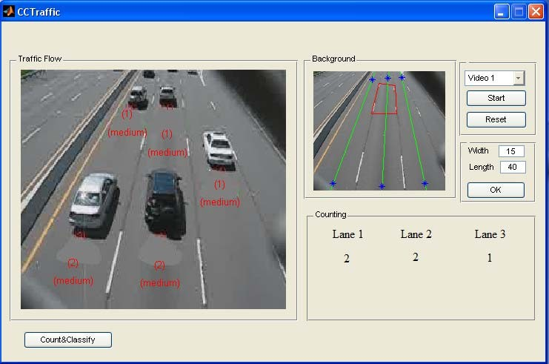

Fig 10: GUI interface of the developed CCT system.

REFERENCES
- R. Chellappa “Vehicle detection and tracking using acoustic and video sensors”, 2004
- Sensor Line, Classax, Traffic Data Acquisition System, Germany, www.sensorline.de
- S. Gupte, “Detection and Classification of Vehicles”, University of Minnesota 2002.
- E. Atkociunas, "Image Processing in Road Traffic Analysis", Vilnius University, 2005
- B. Coifman "A Real-Time Computer Vision System for Vehicle Tracking and Traffic Surveillance" University of California, 1998
- C. Zhang "Adaptive Background Learning for Vehicle Detection and Spatio- TemporalTracking", IEEE, 2003
- R. Cucchiara “Vehicle Detection under Day and Night Illumination" Proc. of ISCS-IIA, Special session on vehicle traffic and surveillance, 1999
- Z.W. Kim "Fast Vehicle Detection with Probabilistic Feature Grouping and its Application to Vehicle Tracking", CiteSeer, 2001
- L. Di Stefano, ”Vehicle Detection and Tracking Using the Block Matching Algorithm", Department of Electronics, Computer Science and Systems (DEIS) University of Bologna, IT

Evaluation of People Counting Systems

T. Schlögl¹, B. Wachmann², W. Kropatsch³, H. Bischof³

¹Advanced Computer Vision, Wohllebengasse 6, A-1040 Vienna, Austria
²Siemens AG Österreich, Programm- und Systementwicklung, Graz, Austria
³Pattern Recognition and Image Processing Group, Vienna Technical University, Favoritenstr.
9/1832, A-1040 Vienna, Austria

This paper addresses the problem of the evaluation of people counting systems. The relation between the real people number and the output of the people counting system is used to motivate the computation of the maximum number of people as a scenario and geometry specific quantity which supports the evaluation of the system output. Based on the camera field-of-view we determine the maximum number of detectable people using a basic people model. The maximum number of people is computed for an overhead camera and for an arbitrary oblique camera orientation which is the typical geometry of standard surveillance applications.

- Introduction
Vision-based real-time people counting comprises all techniques which are able to extract the number of people which are present in an observed area of the real world and which satisfy certain constraints of accuracy and performance. This paper emphasizes the idea that scenario- and geometry specific quantities can rise the accuracy of conventional people counting applications.
Recent research in people counting can be divided into techniques using neural-based crowd estimation ([1], [2], [3]) and methods which are based on blob detection and blob tracking ([4], [5], [6]). Both approaches are rather different from each other. The former employ simple image processing techniques for the extraction of significant features and feed those into a trained neural network to obtain an estimation value of the people in the scene. The accuracy of those systems depends strongly on the training set of the neural network and on the choice of the feature set.
Typical elements of the feature set are the length of the edges and the background area ([1], [2]). People counting by blob tracking is currently an option of systems which are mainly aimed to classify objects and their activities by analyzing their shapes and their trajectories. Those systems

are based on the capability to separate an object from the background. In scenarios where people are crowded, those systems have a poor accuracy since precise object extraction is hardly possible [5].

- Output Accuracy
The output accuracy of a people counting application is evaluated by the relation between the true number of people N_{real} and the mean output of the people counting system N_{out}. Examples for those relations are illustrated in Figure 1. The straight line between the origin and the point (n_{max}, n_{max}) is the ideal case, of course. The diagram illustrates that an overall error in percent is no reasonable measure. Obviously, an error of 30 percent near n_{max} can cause a people number which even exceeds the maximum value. Curve a shows the optimum case of a people counting system which yields always the correct number. Curves b and c show possible variations.
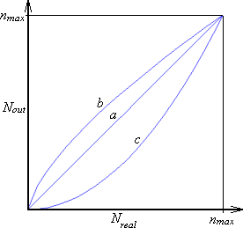
Figure 1: Typical relations between mean output and real people number obtained from people counting systems: Every line represents a relation between the mean output of a people counting system and the real number of people in the viewing area.

Figure 1 incorporates two constraints which can be used for the evaluation of current people counting techniques:
- If there are no people in the viewed area, the people counting system must yield zero.
- For every viewing area, there is a maximum number of people n_{max} who can gather there. The counting system must never exceed this value.

Constraint 1 is trivial and motivated naturally. Most current visual surveillance systems do provide information to human operators concerning the occurence of people within an area. Thereby, the decision whether no person or at least one is present, has a high priority and is of particular importance in security applications.

Constraint 2 includes the requirement that the maximum number of people n_{max} of a scenario must be known. Of course, the number is closely related to the chosen people model. The use of this essential number in people counting applications has not been published so far.

  - Neural-based crowd estimation
Constraint 1 is a critical point for people counting methods based on neural network estimators. They can hardly cope with this constraint since the image processing for feature extraction does not classify edges or blobs at all. Thus, they are sensible to other objects than people, shadows and ambient illumination changes. E. g., in [2], the evaluation of the proposed methods was not performed in respect to this condition. The maximum number of people in the scene is used implicitly in the training set. Good training data are spread over the whole range of possible numbers of people. Thus n_{max} is implicitly used during training, when images with the maximum density are fed into the training algorithm. But generally, there is no proof that n_{max} can not be exceeded by performing the estimation algorithm for images not in the training set.

  - Blob techniques
The capability of blob techniques to fulfill both constraints depends on the reliability and robustness of the realized blob detection and blob classification. Since blobs are analyzed based on their size and their shape [5], blob techniques have the general capability to separate humans from other objects. Thus, it is expectable that they fulfill constraint 1 more likely than neural network estimators. Similarly, constraint 2, the maximum number of people n_{max} must not be exceeded which can be evaluated by counting the blobs and comparing it to the theoretical value.

  - Parametric human body model
The computation of the maximum number assumes the definition of a person model. Figure 2 illustrates the people model which is used in this paper.
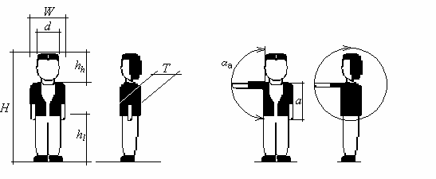
Figure 2: People model: Dimensions used in the computation of n_{max}: H=tallness, W=shoulder width, T=chest depth, D=head diameter, h_{h}=head height, h_{l}=leg length, a=arm length, α_{a}=angle between body and head

- Computation of the maximum number of people
The size of a rectangular area of the video sensor is assumed with S_{W} x S_{B} pixels (the dimension of a pixel element is s_{W} x s_{T}). This area might be the whole sensor area, but can also cover only a smaller part like a bounding box of a blob. First, we do this for the special geometry of an overhead camera and generalize it later to an arbitrary oblique camera orientation.

  - Overhead geometry
This section demonstrates how the minimum number of pixels of the sensor and the maximum number of people can be estimated. All movements of the arms and the legs require more space for a person and reduce the overall number of people. Hence, the motion of arms and legs is neglected.
As Figure 3 illustrates, assuming that there is no sudden vertical movement (e. g. jumping) of a person the actual distance between the closest point of a person and the camera sensor is simply the difference between h and H_{max}. ϑ_{{W,B}} are the viewing angles of the lens of the camera parallel to the side lengths of the sensor. S_{{W,B}} denotes the size of the sensor.

ϑ{W ,B}
= 2 arctan S{W ,B}
2 f

(1)

B_{W} and B_{T} are the projection lengths of the shoulder width W and the chest depth T respectively. Both lengths determine the bounding box of the projected upper body within the image plane. The minimum size of that person, approximated as a rectangle, is evaluated according to the basic projection equations [7]. f denotes the focal length.

object size. f
B =
object distance − f
(2)

If the object distance is much greater than the focal length, the denominator is approximately equal to the object distance.

B = W W
f
h − H
f
(3)

B = T
T
h − H
(4)

Those lengths are converted into pixel dimensions using equations (6) and (7). The use of the maximum value of both side lengths ensures a minimum number of pixels (Equation (8)). In image analysis the sampling interval should be less than or equal to half of the smallest interesting detail in

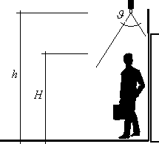
the image in both dimensions [8]. This means that the required number of pixels representing an object must be doubled (in one dimension) due to the sampling theorem.

Figure 3: Camera orientation of an overhead scenario: The geometry is determined by two geometrical parameters, h and ϑ.

smax
= max(sW , s B )
(5)

noverhead
= 2.⎡ BW ⎤

(6)

W ⎢ smax ⎥

noverhead
⎢ ⎥
⎡ B ⎤
T
= 2.

(7)

T ⎢ smax ⎥
⎢ ⎥
The desired value of the maximum number of people in an overhead scenario follows as a ratio of the rectangular sensor area and the minimum area of a single person.

⎡
noverhead = ⎢
⎤
SW .SB ⎥

(8)

max

⎢ noverhead .noverhead ⎥

⎢ W T ⎥

  - Oblique geometry
The variety of the spatial conditions of actual realities in potential locations like waiting areas of supermarkets and banking halls makes it difficult to make any preconsiderations of the components. In contrast to a vertical camera orientation, the distance to the separate persons may vary.
Thus the required resolution is primarily determined by a person observed at the maximum distance L which is determined by the scene geometry. Substituting L instead of h-H into equations
(3) and (4), the resulting value is the estimated maximum.

Equations (5), (6) and (7) allow the computation of the minimum size of a person onto the sensor.

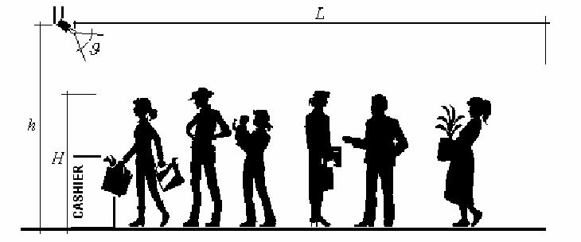
Figure 4: Oblique camera orientation: Monitoring a queue

noblique
⎡
= 2.
W . f ⎤

(9)

W ⎢ smax L ⎥

noblique
⎢
⎡
= 2.
⎥
T . f ⎤

(10)

T ⎢ smax L ⎥
⎢ ⎥
T is the chest depth, s is the size of the video sensor and L is the maximum length of the queue shown in Figure 4. Replacing T_{min} by the corresponding minimum values for shoulder width and tallness equation (9) yields the minimum size of a projected person. Thus, the maximum number of people within the rectangular area of the sensor S_{W} x S_{B} is computed according to equation (11).

⎡
noblique = ⎢
⎤
SW .SB ⎥

(11)

max
⎢ oblique
⎢ n .n
W
T
oblique ⎥
⎥
⎥

- Experimental Results
We implemented a motion detection algorithm based on an adaptive background and threshold model. The application of intensity profile analysis as proposed in [9] allows the detection of stationary and transient objects. The blob information was generated by morphological operations. The parameters of the people model (Figure 2) were used to classify the stationary and transient blobs into two classes: people and other objects. The relevant parameters of the people model were set to H=100...210 cm and W=30...80 cm. All blobs which have the appropriate size were counted for the overall people number. No blob analysis or correlation between successive frames was done.

This algorithm was applied to two test videos recorded at an oblique camera geometry in a railway station in Vienna. Figures 5a and 5b show two snapshots where the people density is very low and where constraint 1 is evaluated. The abscissa indicates the frame number of the video sequence

while the ordinate gives the overall people number. Figure 5b illustrates that the person in the lower part of the scene does not fulfill the people model and is therefore not detected as human.

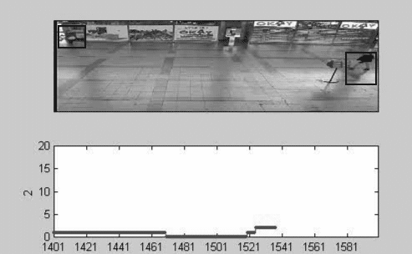
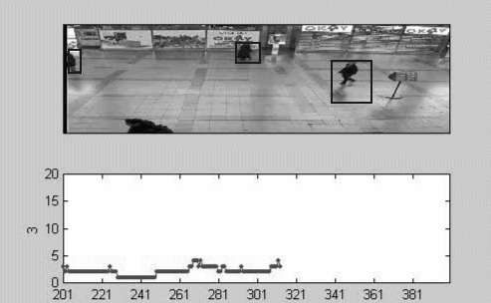
Figure 5: Detection of people at low densities: (a) Proper detection of two people, (b) critical case where a person in the foreground is not detected properly

Figure 6 shows the application of the algorithm for higher people densities. The bounding boxes illustrate that the algorithm is not able to distinguish people which occlude each other properly. This is not surprising since no blob analysis was performed. The maximum number of people which can be found within such a blob is computed using equation (11). This value is used as a reference value for an estimator of the people number in this blob.
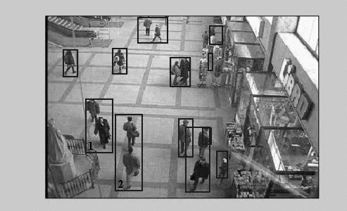

Figure 6: Blob detection: The sizes of the bounding boxes of blobs 1 and 2 indicate that more than a single person is contained. Equation (11) allows the computation of the maximum number of people for every single blob.

The camera was calibrated by measuring the bounding box in pixels of an object of known dimension placed at the nearest and farest point of the viewing area. The computation of the size of each detected blob S_{W} x S_{B} was interpolated linearly. Similarly, length L of equations (9) and (10) was linearly approximated from the total depth of the viewing area.

- Conclusions
We described how the two current approaches of automatic people counting algorithm deal with our suggested constraints for the evaluation process. Based on the camera field-of-view and a basic people model, it was shown how the maximum number of detectable people is computed for overhead and oblique camera orientations.

- References
- C. S. Regazzoni, A. Tesei, „Distributed data fusion for real-time crowding estimation“, Signal Processing 53, pp. 47-63, 1996.

- S.-Y. Cho, T. W. S. Chow, C.-T. Leung, „A Neural-Based Crowd Estimation by Hybrid Global Learning Algorithm“, IEEE Transactions on Systems, Man and Cybernetics – Part B: Cybernetics, Vol. 29, No. 4, August 1999, pp. 535-541.

- T. W. S. Chow, J. Y.-F. Yam, S.-Y. Cho, „Fast training algorithm for feedforward neural networks: application to crowd estimation at underground stations“, Artificial Intelligence in Engineering, Vol. 13, pp. 301-307, 1999.

- V. Kettnaker, R. Zabih, „Counting People from Multiple Cameras“, IEEE International Conference on Multimedia Computing and Systems, Vol. 2, pp. 267-271, 1999.

- I. Haritaoglu, D. Harwood, L. S. Davis, „W⁴: Real-Time Surveillance of People and Their Activities“, IEEE Transactions on Pattern Analysis and Machine Intelligence, Vol. 22, No.8, August 2000, pp. 809-830.

- R. T. Collins, A. J. Lipton, T. Kanade, H. Fujiyoshi, D. Duggins, Y. Tsin, D. Tolliver, N. Enomoto, O. Hasegawa, P. Burt, L. Wixson, „A System for Video Surveillance and Monitoring“, Carnegie Mellon University, CMU-RI-TR-00-12, 2000.

- F. Matossi, „Bergmann Schaefer: Lehrbuch der Experimentalphysik“, Bd. III, Optik, 4th Edition, Walter de Gruyter & Co., Berlin 1966, p. 75.

- M. Sonka, V. Hlavac, R. Boyle, „Image Processing, Analysis and Machine Vision“, 1st Edition, Chapman & Hall Computing, 1993.

- R. T. Collins, A. J. Lipton, T. Kanade, H. Fujiyoshi, D. Duggins, Y. Tsin, D.Tolliver, N. Enomoto, O. Hasegawa, P. Burt, L. Wixson, „A System for Video Surveillance and Monitoring“, Carnegie Mellon University, CMU-RI-TR-00-12,

View publication stats

INTELLIGENT PEOPLE AND VECHICLE COUNTING SYSTEM FOR SECRETARIAT

PRESENTED BY

JAYAPRIYA R -912520104013

INDHUMATHI E -912520104011

SIVADHARSHINI S -912520104029

MANOJ A -912520104303

SURYA M -912520104030

People Counting in Transport Vehicles

Sebastien Harasse, Laurent Bonnaud, Michel Desvignes
LIS-ENSIEG, 61 rue de la Houille Blanche BP 46 38402 St. Martin d’Heres cedex France

{harasse,bonnaud,desvignes}@lis.inpg.fr

Abstract— Counting people from a video stream in a noisy environ- ment is a challenging task. This project aims at developing a counting system for transport vehicles, integrated in a video surveillance product. This article presents a method for the detection and tracking of multiple faces in a video by using a model of first and second order local moments. An iterative process is used to estimate the position and shape of multiple faces in images, and to track them. the trajectories are then processed to count people entering and leaving the vehicle.
Keywords— face detection, tracking, counting, local statistics

- INTRODUCTION
E
STIMATING the number of people in a noisy environ- ment is a central task in surveillance. A real-time count
can be used to enforce the occupancy limit in a building, to manage transport traffic in real time, to actively manage city services and allocate resources for public events. Our project is to develop a counting system for moving platforms such as
- STATISTICAL MODELING AND SKIN OBJECT DETECTION
The method proposed here is based on skin color infor- mation, since it is the most robust information in cluttered environment. The main steps of our counting system are the probabilistic skin color modeling, the iterative face detection, tracking and counting.

- Skin color model
A skin color model is needed in order to decide whether a pixel is skin colored or not. Skin chrominance is very specific, as opposed to its luminance, which has a large variability. Thus our model is defined in a chrominance color space so that skin pixels are represented in a small portion of the space, for example the normalized-rgb color space, defined from the original RGB space as:

buses, in an existing classical video recorder. Images are cap- tured using a video camera and are analyzed to determine the
r =
R + G + B
R
, g =
R + G + B
G
, b =
R + G + B
B
(1)

number of people present. The background scene is therefore not static and vary in a large number of ways: variations in lighting levels, patterns of scene background, movements of objects that might appear or disappear in the scene. The point of view is defined by the location of the camera, in front of the people. This motivates our approach, which is to detect, track and count faces, using color information. This paper propose a method to detect and track multiple skin objects using local moments, with two different movement prediction methods. The estimated trajectories of faces are then used to count people.

II. PREVIOUS WORK
Finding people in images is a difficult task [1] due to the high variability in appearance of people. Various approaches have been proposed in the past years [2], [3], including meth- ods based on background subtraction [5], classical template matching with several patterns [8], [9], [10], [11] and statistical classifiers such as support vector machines [12], [13] or neural networks [14], [15] applied to face features vectors. However, most face detection methods use skin color information [2], [3], which is a low level and accurate information. The tracking of multiple targets in a video sequence in a cluttered environment can be done with particle filtering [16]. This paper presents a novel method for multiple targets tracking which
Since r + g + b = 1, only two components (r,g) are used for the model. A bidimensionnal gaussian model g_{skin} is obtained to represent skin color in the rg-space. Its parameters are learned from skin pixels from the FERET faces database [19]. This model is applied to an image to obtain a skin map S_{I} where each value is the value of our bidimensionnal gaussian model at the corresponding pixel’s color. For an image I, and
skin model g_{skin}, the corresponding skin map S_{I} is:
S_{I} (x, y)= g_{skin}(I(x, y)) (2)
where (x, y) is a position in the image and I(x, y) is the color of I at this position, in normalized-rgb coordinates. Fig. 1(b) presents an example of skin map.

- Statistical modeling
Our face detector is based on a statistical representation of the problem: a face is a skin region, parameterized by its position and shape. Therefore a skin object x is assumed to be a 5-dimensional vector composed of the first order moment, describing position, and the second order moment, describing shape:

x = (µ_{x}, σ_{x}) (3)
with

is based on a statistical modeling of the problem, like the Condensation algorithm, but does not require sampling.

µ_{x} = (µ_{x1}

, µ_{x2}

), σ_{x}
= σx11 σx12
σx12 σx22
(4)

Our face model can be seen as an ellipse centered in µ_{x} with axes defined by covariance matrix σ_{x}. This model has been
introduced in [17] for one single face tracking using color. The problem can be expressed as a statistical detection
A sequence of local moments is defined as:
σ₀ =1
(9)
σ
2
n+1
= σ
2
Sz ,g(µx0 ,ασn )

problem, where x is a random variable and z another ran- dom variable whose realizations are each image. We aim at detecting the local maxima of the observation density p(z/x), in order to find the parameters of each skin object in the image. p(z/x) is defined as proportional to the correlation between the skin map S_{z} and the bidimensional gaussian function g_{x} parameterized by x:
∫

p(z/x) ∝
S_{z}(t).g_{x}(t)dt (5)
where g(µ_{x}0 , ασ_{n}) is the bidimensional gaussian window of first and second order moments µ_{x}0 and ασ_{n} respectively, with α a real scalar found experimentally, so that the sequence converges: α 1.3.
Practically, the method consists in starting with a window centered in µ_{x}0 with a size smaller than the expected object size, computing the local moments of S_{z} in this window, then using the result multiplied by a constant α as the next window
≈
covariance matrix. This sequence converges to the second order moment of the skin object. By using local moments,

with t a bidimensional variable.
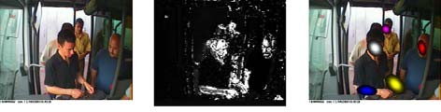

Fig. 1. (a) original image, (b) skin map , (c) five detected objects

- Skin objects detection
The method proposed here estimates µ_{x} by using a priori information about σ_{x}, then estimates σ_{x} for each detected object, using an iterative process.
  - First order moment estimation: the detection of the first order moments µ_{x} of objects in the image involves an a priori estimation of σ_{x}. σ_{m} is defined as the average covariance matrix representing a face. With this assumption, the observation density becomes:
p(z/µ ,σ = σ ) ∝ ∫ S (t).g (t)dt (6)
the computation of σ_{x}0 is not disturbed by the other objects in the image. The detection of multiple skin objects in the image can then be achieved. Fig. 1 shows the results obtained with this method.

- SKIN OBJECT TRACKING
Our method for temporal tracking of detected skin objects is tightly related to the recursive method used for the second order local moment estimation. The tracking is composed of a prediction step followed by an observation step for each object.

- Trajectory prediction
Our tracker is designed to track several objects simultane- ously. One major difficulty in multiple targets tracking is the association problem: each object detected at time t must be associated to its corresponding object at time t + 1.
Two different prediction methods are considered: dynamic model based prediction and trajectories learning based predic- tion.
  - Dynamic model based prediction: the first and most common method is to define a dynamic model for the object, estimate its parameters from past observations, and predict the

x x m
z µx,σm
next state from this model. In our application, faces movement
is difficult to predict accurately since framerate is low and

p(z/µ_{x}, σ_{x} = σ_{m}) ∝ ∫ S_{z}(t).g_{0,σ}m (t − µ_{x})dt (7) with g_{µ,σ} denoting the gaussian function with first and
second order moments µ and σ respectively.
The observation density with fixed σ_{x} = σ_{m} is proportional to the 2-dimensional convolution product of S_{z} by a gaussian function with covariance matrix σ_{m}, which is an inexpensive computation. The first order moments of objects are detected by finding local maxima of the function.
  - Iterative second order moment estimation: suppose that an object x₀ is present in the image, with first order moment µ_{x}0 . Its second order moment σ_{x}0 must be estimated.
Our method is to estimate σ_{x}0 by using local moments iteratively. Let W be a 2-dimensional window defined in the same space as S_{z}, with W (t)dt = 1. The second order local moment [18] of S_{z} centered in µ_{x}0 is defined as:
∫
∫
σ2
0

Sz ,W
=
(t − µ_{x} )².S_{z}(t)W (t)dt (8)
people are close to the camera. This results in a very noisy trajectory.
Therefore, a simple but robust model is used: the tracked object is assumed to have a constant speed vector for a relatively small amount of time (about one second). The speed vector is estimated from the past positions of the object during the last second, to filter out noise. A more complex model could be used if needed by the application.
2) Trajectories learning based prediction: the second pre- diction method aims at predicting the next state of one object by using the estimated trajectories of past tracked objects. In our application, people are passing in front of the camera by following almost the same path every time. Thus it is possible to learn people trajectories and use this information to predict the states of future objects. A way to learn the trajectories is to store for each state, the estimated next state of tracked objects that have had this state. That is to say, for an object tracked at time t with state x^{t} , its estimated state x^{t+1} at time
O
O
t +1
is stored in a table. When another tracked object state

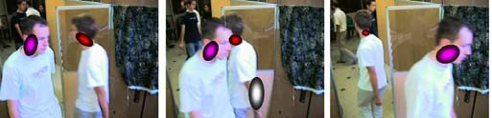
is similar to x^{t} , its predicted state must be similar to x^{t+1}.
O O

For memory considerations, only the position part of the state vector is learned.
A tracked object has only a small probability to be estimated at the exact same state as another object. It is therefore necessary to predict the next state of an object O from the learned trajectories of other objects that presented a state close to the O object’s current state. All memorized state predictions close to the object O current state are taken into account.
An a priori probability density is defined for object O’s next state, from the memorized trajectories, as:
N

Fig. 2. Tracking example, two people passing each other

in the second frame to estimate the state of the target. The decision is made by computing the ratio of skin pixels by the area of the ellipse parameterized by the estimated second order

p(x^{t+1}/x^{t} ) ∝ Σ f (ǁµ_{x}
— µ_{x} ǁ).g
(10)
moment:

O O
k=1
_{k} _{O} P (x_{k})

O
A = ∫ z(t)W_{lim}(t)

(13)

with N the number of entries in the trajectories table, x^{t}
the current state of object O, x^{t+1} its predicted state, x_{k} the
O
with W

lim
area(W_{lim})
the gaussian window parameterized by the limit

k − th memorized state, P (x_{k}) the learned predicted state
for state x_{k}, and g_{P} _{(x}k ) the bidimensional gaussian function parameterized by x_{k}. f is a positive decreasing function.
Since only the predicted position of skin objects are memo- rized, the second order moment part of state x_{k} is considered
of sequence σ_{(n)}. A is compared to a reference ratio A_{ref} .
When a target is lost, the predicted state is assumed to be the estimated state. If the target is lost for too much time, it is considered definitely lost.

equal to the second order moment σ^{t} of object O at current

O
time t.
This prediction is integrated in our tracking algorithm by using this probability density as the initial window to estimate the local moments for the object in the next image.

- Observation step
The observation step corrects the predicted position and shape of the object with respect to the observed image. The gaussian function parameterized with the predicted state defines the window in which the first and second order local
- PEOPLE COUNTING
The counting of people is done in a simple way, by counting the tracked objects crossing a segment defined in the image space. The segment is defined manually so that the faces cross it when people enter the vehicle. The counting of a target tracked from position P₁ at a frame to position P₂ at the next frame, is done by checking if P₁P₂ crosses the counting segment C₁C₂, with dotproduct and crossproduct tests:
⎪⎪⎧ 1 1 1 2
−C−−P→.C−−−.C→ > 0
−C−2−P→1.−C−2−C→1 > 0
⎪
⎨ −1 2 1 2

moments of the object are computed. This step is iterated by using the last computed local moments as the parameters of the gaussian window:
−C−−P→.−C−−.C→ > 0
C−2−P→2.−C−2−C→1 > 0
⎪
⎪ 1 1 ∧ 1 2
(14)

µ0 = µpredicted
−C−−P→ −C−−C→ < 0
⎩ −C−1−P→2 ∧ −C−1−C→2 > 0

⎨ σ0 = σpredicted
= µS ,g(µ ,ασ )
⎩⎪
µ
(11)
This counts people passing from left to right, as illustrated
in figure 3. To count people passing from right to left, the two

n+1 _{z} _{n} _{n}
σ² = σ²
last inequalities are reversed:

n+1
Sz ,g(µn,ασn )

with µ_{S}z ,g(µn,ασn ) the first order local moment of S_{z} in the window g(µ_{n}, ασ_{n}), defined by:
−C−−P→ −C−−C→ > 0
−C−−P→ ∧ −C−−C→ < 0
∧1 1 1 2

(15)

∫ 1 2 1 2
µSz ,g(µn,α.σn ) =
t.S_{z}(t).g(µ_{n}, ασ_{n})dt (12)
The main advantage of this method is that if the tracking fails before or after the counting segment but succeeds at the

In this sequence, the σ update step is the same as in (9). This
sequence converges to the first and second order moments of each object for the current image. figure 2 shows an example of the tracking of two faces (red and violet ellipses). One arm is also detected in the middle image (white ellipse).

- Targets occlusions
Our system must be robust to temporal targets occlusions, that can appear because of a scene object or another target crossing the first one. A target is considered lost from one video frame to the next when there is not enough information
counting segment, the face will be counted.

- RESULTS AND CONCLUSION
The counting method has been tested under controlled con- ditions, in an indoor office, as well as under real conditions, on video streams from a transport vehicle. Using an appropriate skin model, the detection and tracking of skin objects is efficient, with a few tracking loss because of illumination conditions changes. By using an adaptive color skin model, it would be possible to achieve better tracking. A 85% counting success rate is achieved compared to the real count, while most

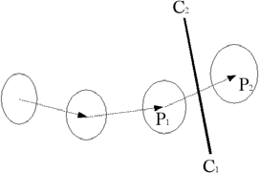
  - M. Isard and A. Blake, “Condensation – conditional density propagation for visual tracking”, International Journal of Computer Vision 29(1), pp. 5–28, 1998.
  - K. Schwerdt and J. L. Crowley, “Robust face tracking using color”, in Proc. of 4th International Conference on Automatic Face and Gesture Recognition, Grenoble, France, 2000, pp. 90–95.
  - M-K. Hu, “Visual pattern recognition by moment invariants”, IRE Trans. on Information Theory, IT-8:pp. 179-187, 1962.
  - P. J. Phillips, H. Moon, P. J. Rauss, and S. Rizvi, “The FERET evaluation methodology for face recognition algorithms”, IEEE Transactions on Pattern Analysis and Machine Intelligence, Vol. 22, No. 10, October 2000.

Fig. 3. Skin object crossing the counting segment

non detection were caused by faces not passing through the counting segment. False positives were caused by some arms being counted.
The main features of our approach are the iterative local moments estimation, the absence of threshold for the detection of skin pixels and objects, and the trajectory prediction based on learning of past trajectories. We are currently working on improving the skin color model to achieve a better detection of skin pixels.

REFERENCES
- S. Ioffe, D. A. Forsyth, “Probabilistic Methods for Finding People”. International Journal of Computer Vision 43(1), pp 45-68, 2001.
- M.H. Yang, D. Kriegman, and N. Ahuja. “Detecting face in images: a survey”, IEEE Transactions on Pattern Analysis and Machine Intelli- gence, 24(1), pp 34-58, 2002.
- Erik Hjelmas “Face Detection: A Survey”, Computer Vision and Image Understanding, 83(3), pp. 236-274, 2001.
- C. Wren, A. Azarbayejani, T. Darell, A. Pentland, “Pfinder: Real-time tracking of human body”, IEEE Trans. on Pattern Analysis and Machine Intelligence, 19(7), pp. 780-785, 1997.
- I. Haritaoglu, D. Harwood, and L. Davis, “W4: A real-time system for detection and tracking of people and monitoring their activities”, IEEE Pattern Analysis and Machine Intelligence, 22(8), pp. 809-830, 2000.
- Collins, Lipton, Kanade, Fujiyoshi, Duggins, Tsin, Tolliver, Enomoto, and Hasegawa, ”A System for Video Surveillance and Monitoring: VSAM Final Report,” Technical report CMU-RI-TR-00-12, Robotics Institute, Carnegie Mellon University, May, 2000.
- G. Yang, T.S. Huang, “Human face detection in complex background”, Pattern recognition,27(1):53, 1994.
- Y.H. Kwon and N. da Vitoria Lobo, “Face Detection Using Tem- plates”,International Conference on Pattern Recognition, pp. 764-767, 1994.
- H. Nanda and L. Davis, “Probabilistic template based pedestrian de- tection in infrared videos”. IEEE Intelligent Vehicles, 2002, Versailles, France, pp 15-20, 2002,
- M. Bertozzi et al, “Pedestrian detection in infrared images,” IEEE Intelligent Vehicles Symposium 2003, Columbus, USA, pp662-667, 2003
- C. Stauffer and E. Grimson, “Similarity templates for detection and recognition”, Computer Vision and Pattern Recognition, pp. 221-228, Kauai, HI,. 2001.
- P. Campadelli, R. Lanzarotti, G. Lipori, “Face detection in color images of generic scenes”, International Conference on Computational Intelli- gence for Homeland Security and Personal Safety (CIHSPS), 2004.
- F. Xu, X. Liu, and K. Fujimura, “Pedestrian Detection and Tracking with Night Vision”, IEEE Transactions on Intelligent Transportation Systems, 5(4), 2004
- L. Zhao and C. Thorpe, “Stereo- and neural network based pedestrian detection”, IEEE Int. Conf. on Intelligent Transportation Systems, Tokyo, Japan, pp 148-154, 2000.
- H. Rowley, S. Baluja, T. Kanade, “Neural Network-Based Face De- tection,” IEEE Trans. Pattern Analysis and Machine Intelligence,20(1), pp.23-38, 1998.

PWASET VOLUME 4 FEBRUARY 2005 ISSN 1307-6884 224 © 2005 WASET.ORG

View publication stats

